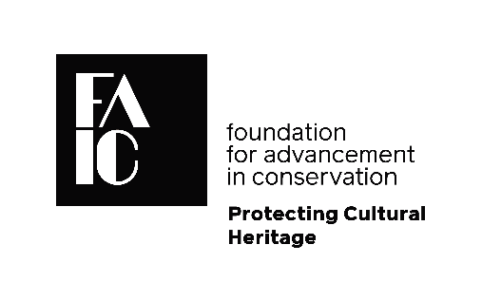
FAIC Planned Giving Form
The Foundation for Advancement in Conservation (FAIC) supports conservation education, research, and outreach activities that increase understanding of our global cultural heritage. Our mission is to save cultural heritage for future generations, protecting it from decay and destruction.
Including FAIC in your estate planning is a great way to have a lasting impact on our work and leave behind a legacy of support for the conservation profession. You can name FAIC as the beneficiary of planned gifts such as bequests, retirement funds, and insurance policies, and of life income gifts such as charitable remainder trusts and charitable remainder annuity trusts. Some planned gifts allow you to enjoy tax and income benefits during your lifetime while making a significant commitment to the Foundation.

Name ___________________________________________________________________
(Please Print)
Address _________________________________________________________________
Street Address City State Zip
Signature ________________________________________________________________
Telephone _______________________________________________________________
Email ____________________________________________________________________
__ I have included FAIC in my will or estate plans.
__ I have made other estate provisions for FAIC.
__ Please send me more information on providing for FAIC through my will or other
planned giving opportunities.
__ I am enclosing a donation of $_______________
Please return form to FAIC:
By mail: Eryl P. Wentworth, Executive Director By fax: (202) 452-9328
FAIC By email: foundation@culturalheritage.org
727 15th Street NW, Suite 500
Washington, DC 20005 USA

