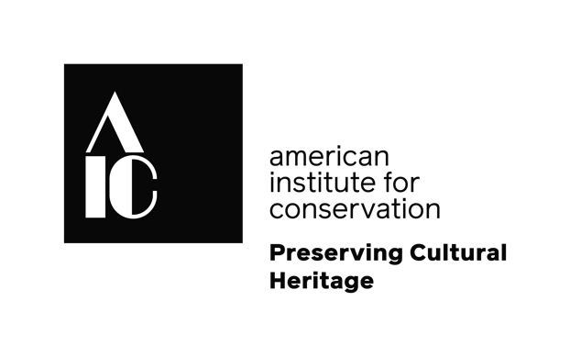

Ask a Conservator Day Sample Social Media Posts:
Individuals:

Conservators! Be part of #AskAConservator day—help raise awareness of what we do by participating. Let your followers know they can ask you questions. Find more information here: http://bit.ly/2nU9531

I’m participating in #AskAConservator day! Conservators around the world will be discussing their work on November 3rd. Ask me questions & follow the hashtag to see who is participating.

I’m participating in #AskAConservator day! What do you want to know about being a conservator? Start asking questions now and I’ll answer them on November 3rd!

Do you have questions about what conservators do? Ask me anything about my work on November 3rd, #AskAConservator day! Reply to this (post/tweet) and use the hashtag.

Institutional/organizational accounts:

We’re participating in #AskAConservator day! Conservators around the world will be discussing their work on November 3rd. Ask us questions & follow the hashtag to see who else is participating.

Do you have questions about how we care for (collections type: i.e. art, building, site, specimens, etc.)? Ask us anything on November 3rd on #AskAConservator Day! You can reply to this tweet or @ us and use the #AskAConservator hashtag.

November 3rd is #AskAConservator day! (Title and name of conservator(s)) will be answering your questions at (time). Bring all of your questions about how we care for (collections type: i.e. art, building, site, specimens, etc.)

What do our conservator(s) do? They care for (notable collections items or types of items). Want to know how they do it? Ask your questions on November 3rd, #AskAConservator day!

Promotional Images:

We encourage you to use images of from your work to make your posts more unique and meaningful, but you can also find promotional images here:

https://drive.google.com/drive/folders/1tbaiYJrrDutyX2S8P6zGywZ317UiBac2?usp=sharing

